Kartik Velede

8672807

INFO8860 – Customer Needs and Analysis Gathering

Professor Janelle Mifflin Starkey

ASSIGNMENT START DATE: October-24-2019

ASSIGNMENT DUE DATE: November-07-2019

**Table of Contents**

**1.UseCase Diagram** 3

**2.DataFlow Diagram** 4

**3.Swimlane Diagram** 5

**4.Feature Tree Diagram** 6

# **1.UseCase Diagram**

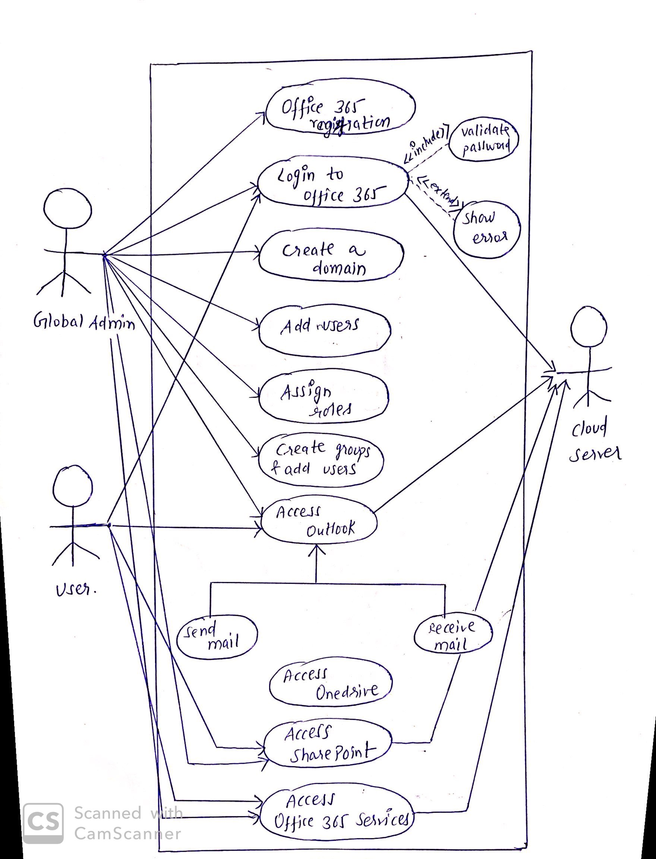

# **2.DataFlow Diagram**

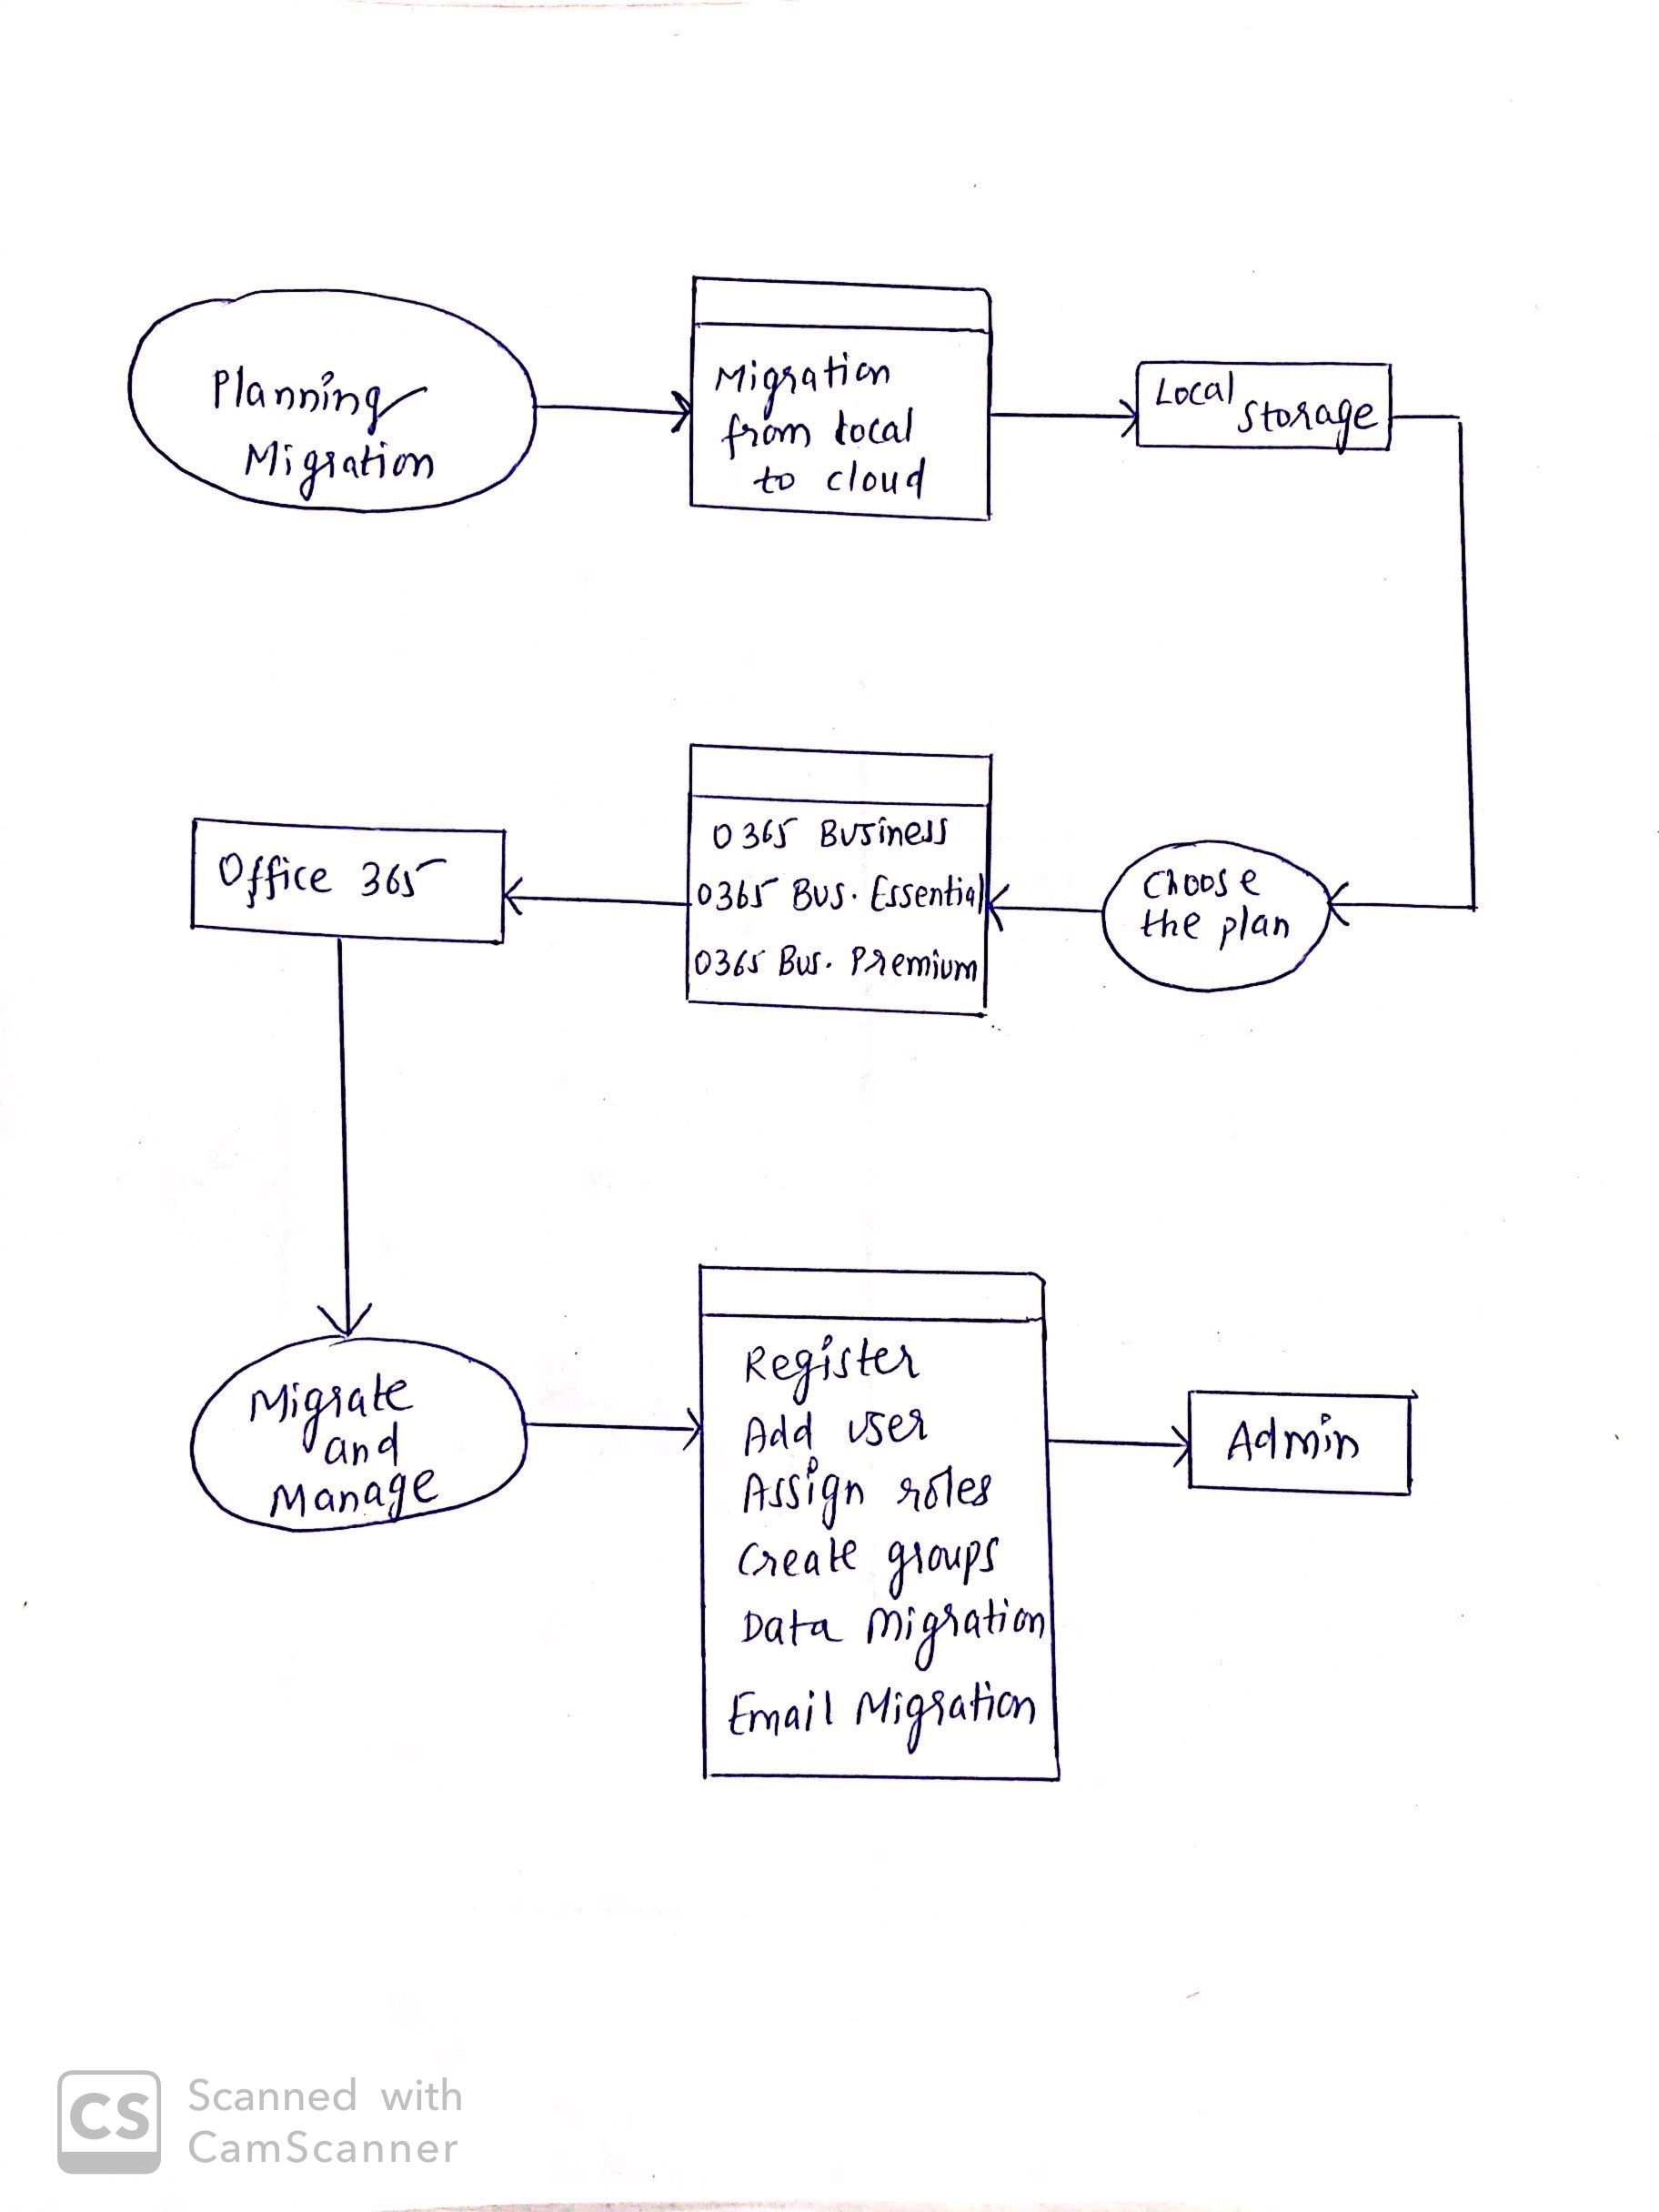

# **3.Swimlane Diagram**

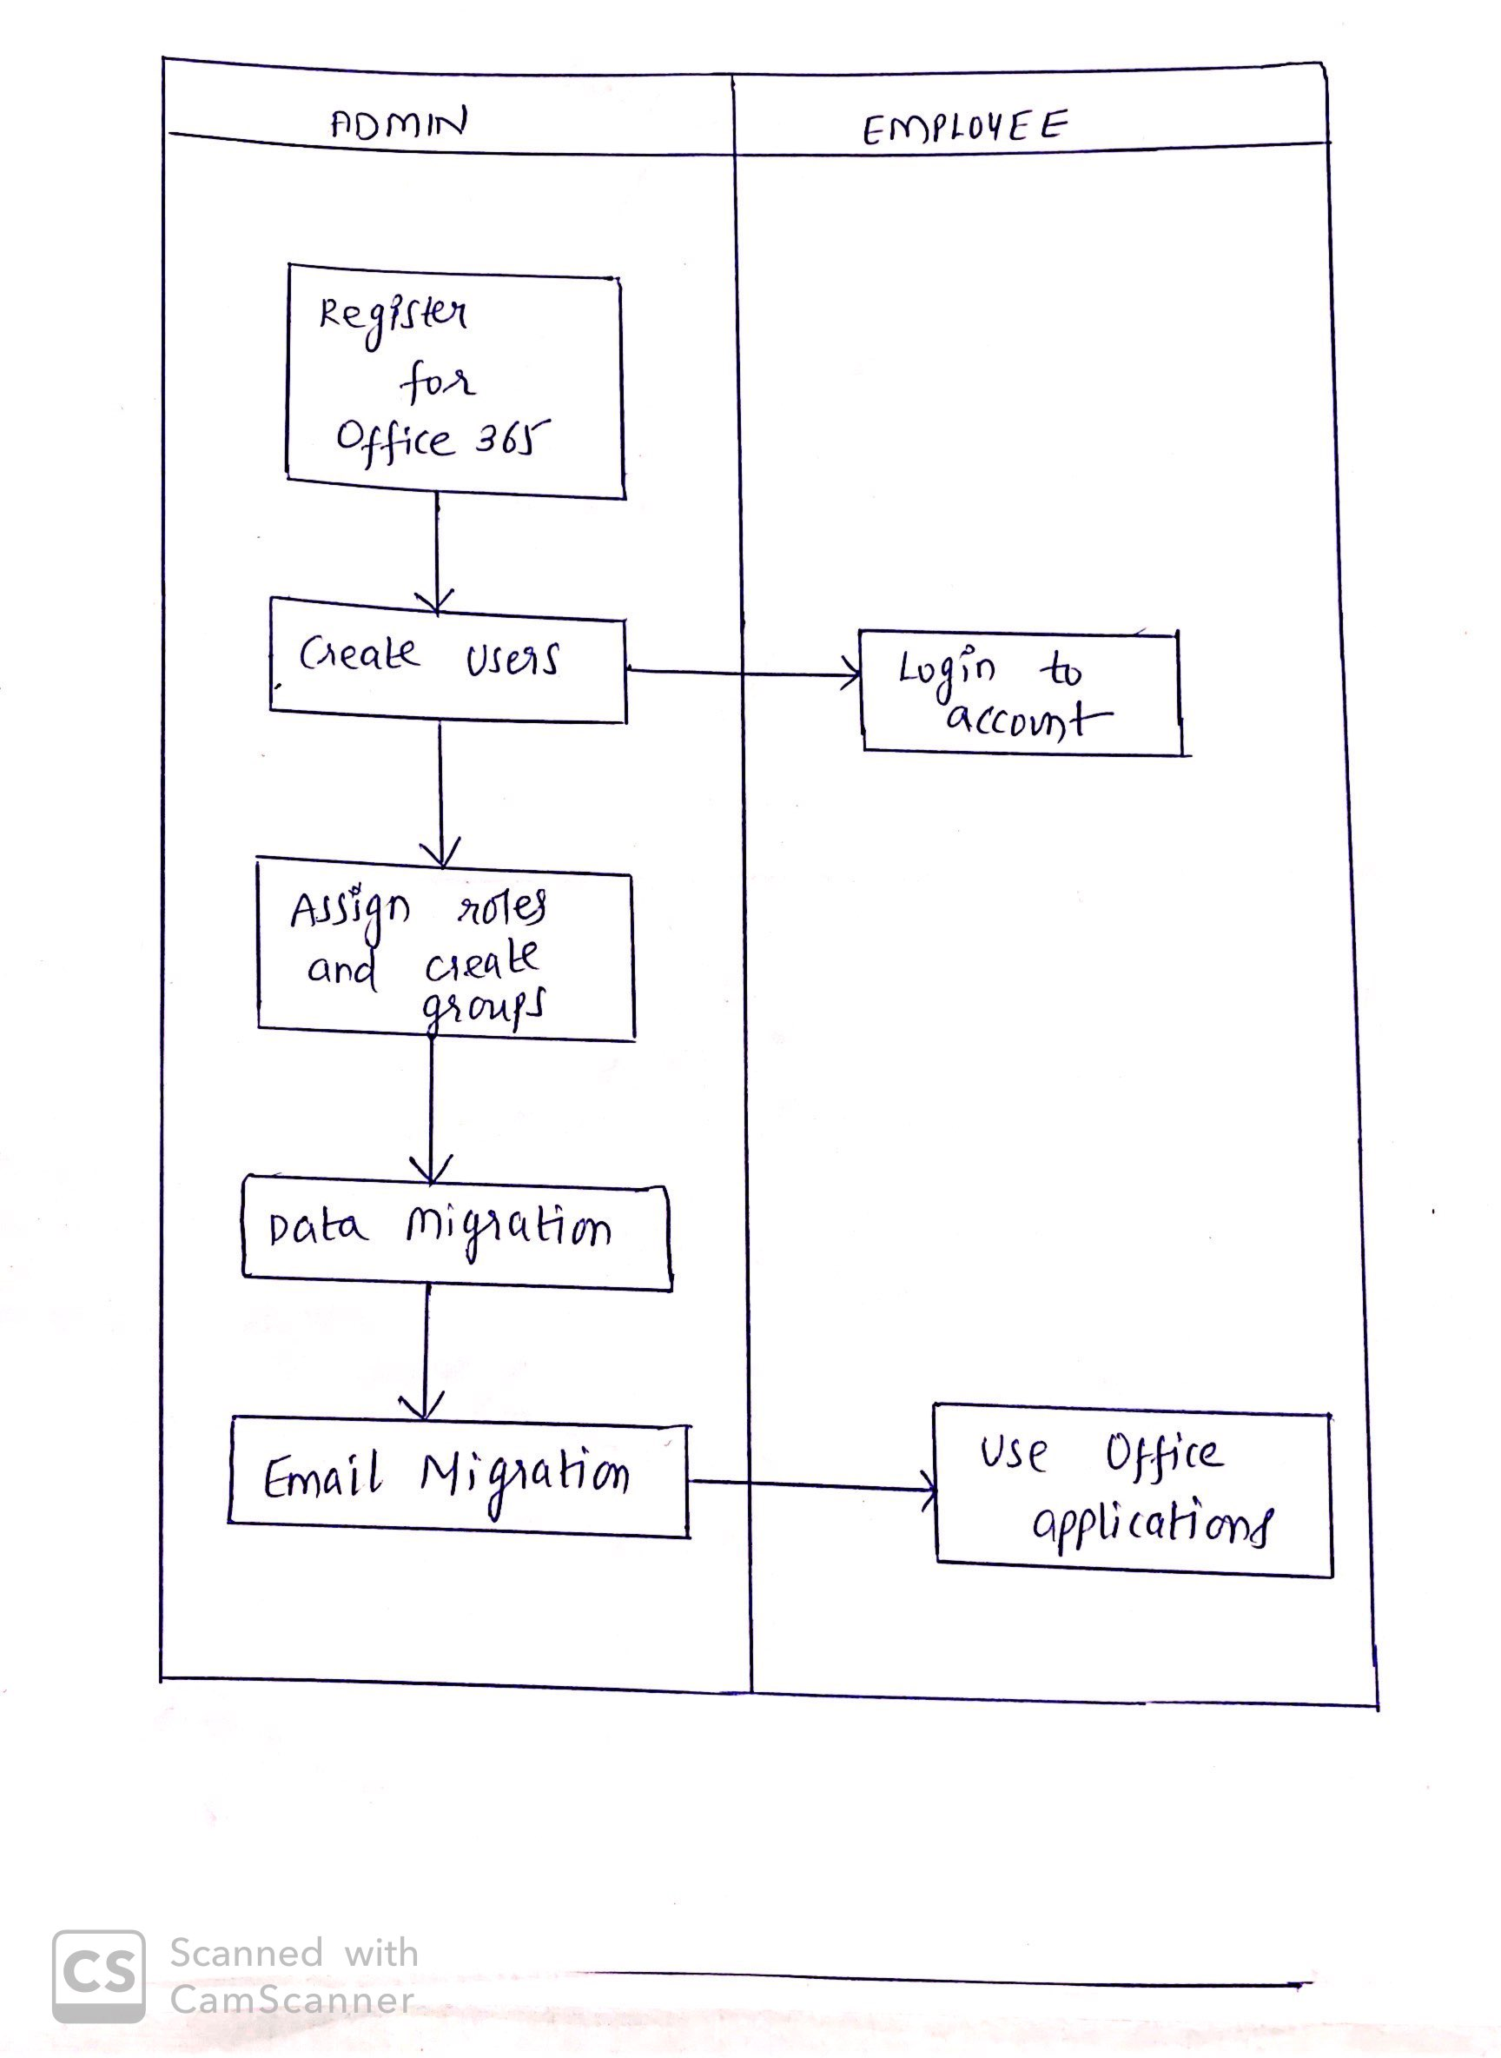

# **4.Feature Tree Diagram**

